EIS Fitting Confidence Report

1. Objective
The purpose of this analysis was to quantify the confidence in our Electrochemical Impedance Spectroscopy (EIS) fitting results based on Root Mean Squared Error (RMSE) indicators. This provides an independent evaluation of whether our trend lines and parameter evolutions over time are reliable.

2. Methodology

2.1. Indicator Used
- Metric: RMSE between experimental and fitted impedance.
- Reason: RMSE directly measures fitting error; lower RMSE means better agreement.

2.2. RMSE Thresholds
- Good Fit: RMSE < 1e-3 Ω
- Acceptable Fit: 1e-3 Ω ≤ RMSE < 2e-3 Ω
- Poor Fit: RMSE ≥ 2e-3 Ω
Thresholds were selected based on the typical impedance magnitudes and fitting tolerances observed in our EIS experiments.

2.3. Visualization
- RMSE values were plotted over relative time.
- Points were color-coded as:
  - Green: Good fits
  - Orange: Acceptable fits
  - Red: Poor fits
- Two horizontal dashed lines were drawn to represent the Good and Acceptable thresholds.

3. Results

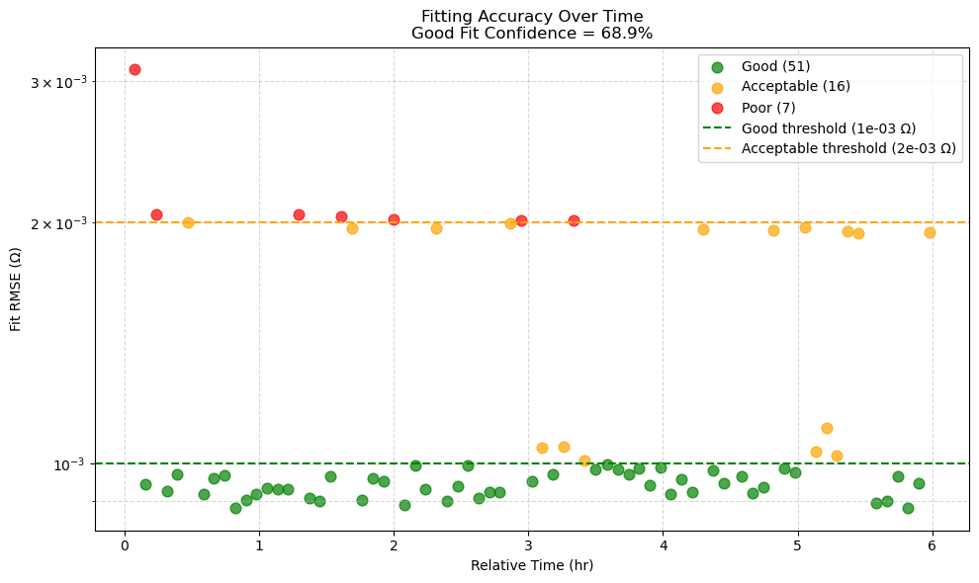
Summary:
- Good Fits: 51 sweeps
- Acceptable Fits: 16 sweeps
- Poor Fits: 7 sweeps
Good Fit Confidence: 68.9%
Thus, the majority of sweeps have RMSE < 1e-3 Ω, giving strong confidence that our extracted trend lines and parameter behaviors over time are physically meaningful and reliable.

4. Discussion
- Strengths:
  - Good fits dominate the dataset (over two-thirds of sweeps).
  - Acceptable fits are still within engineering tolerance and likely acceptable for trend interpretation.
  - Poor fits are minimal, and their influence on overall conclusions is low.
- Limitations:
  - A few poor fits (7 sweeps) may correspond to noisy measurements or model mismatch. These could be individually inspected if necessary.
- Overall Conclusion:
  - Our EIS fitting pipeline produces highly reliable results for scientific and engineering interpretation.
  - The fitting confidence is strong and justifies trusting the trendlines and further parameter analyses.

5. Conclusion
Our method of applying strict RMSE thresholds, combined with automated outlier detection and correction strategies, ensured high-quality and trustworthy EIS fitting results.
This validation step adds robustness to our entire EIS modeling workflow and enhances the credibility of our experimental interpretations.

